domenica 23 aprile 2017

12:36

OPENSPRIKLER SOLAR

A do it yourself project to make OpenSprinkler fully autonomous.

You can use it where there is no power and Ethernet cables.

All you need is a battery powered unit based on Esp8266 a solar panel and few self-latching valve's.

This device is fully compatible with Open Sprinkler units from [Ray](http://OpenSprinkler.com) and with OS firmware.

A short description of the HW necessary to build the Solar Open Sprinkler unit will follow.

RES 
3 TXQC 

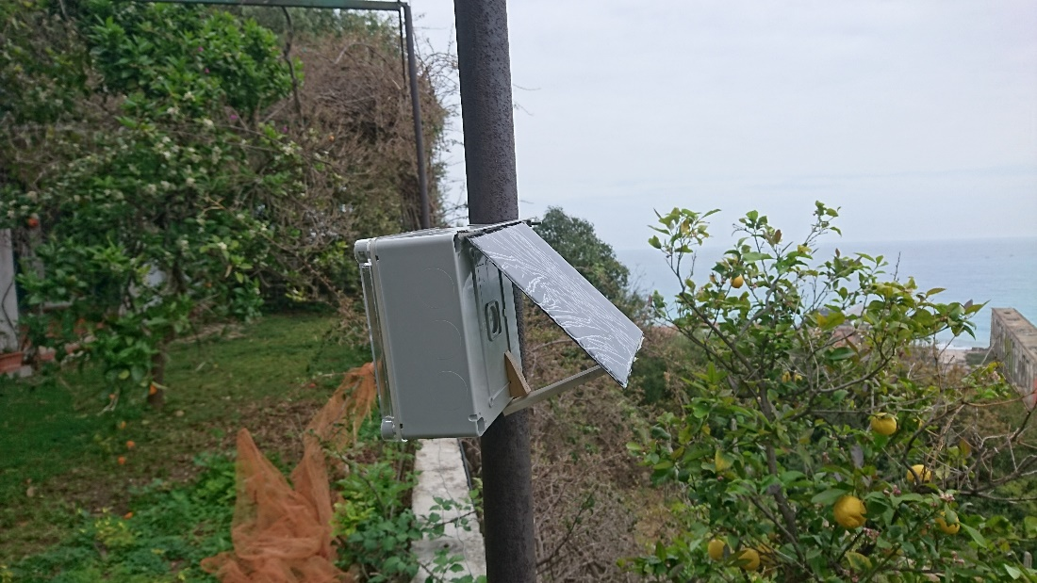

Components List

This is a list of the components I have used in my first OpenSprinkler Solar prototype:

* 1. Solar Panel rated 5v with 5w power
  2. 2 Lipo batteries 3.7v with at least 2600mAh capacity
  3. A Esp8266 MCU ( I have used an Esp8266 201 but any type should go!)
  4. A DPDT 3 v relay
  5. A capacitor 2200uF or more.
  6. A graphic I2c OLED LCD
  7. A relay board with 4 or more 5v relay
  8. A Pcf9574 I2c expander
  9. Pushbuttons, few resistors, 2 40v 1a diodes.
  10. A TP4056 board to charge Lipos
  11. A 3.3 volts voltage regulator IC

Optional:

A RTC board (based on Ds1307 or equivalents)

A Ina219 board to measure battery in&out current and voltage

DESCRIPTION

Self latching solenoids need a short pulse at 9volts to open and , inverting polarity, to close.

To get this high voltage you may build a step-up converter (as in OS Bee 2.0) or use the method of switching batteries from parallel to series using a DPDT relay. Since current absorbed by solenoid is several amps in a very short pulse , best solution is to charge a capacitor that will be discharged to operate the solenoid.

I have used 8 5v relay in a single board to connect the solenoids.3 relays are connected t 3 valve's positive while a 4th relay is connected to all valve's return (negative),the 1st relay drop the charge from the capacitor to the solenoid.

The relay input come from a PCF8574 I2c expander. This IC has 8 IO channels : 5 are used for relays the remain 3 are used for 3 pushbuttons (this way the unit can be operated a standard OpenSprinkler unit).

Regarding power supply I used 2 Lipo18650 with2600 mAh each mounted in parallel and a 3.3v power regulator. Considering an average power drain of 70mA , mainly coming from the ESP, the batteries will last about 70 hours. This will mean about 5 days of cloudy sky, since during daytime the solar panels produce as a minimum 70mA. Batteries are charged with a TP 4056 board that may provide up to 1 amp, so a panel rated 5v 5w will be best choice to charge the batteries.

A full sunny day will charge both batteries completely, so I am confident that the units can operate autonomously without any additional recharge.

Anyhow if batteries discharge, I have provided an hybernation mode that will reduce consumption to less than 5mA.

This way I will preserve batteries and continuous operation of the units ( but no web connection).

To monitor batteries status the Analog input pin of the Esp8266 can be used. I added a Ina219 board that allow precise current and voltage reading ,but it is not essential for the unit operation.

A real time clock can be used to keep clock in case of restart, but the unit can work with the internal clock and an NTP synchronization.

SCHEMATICS

bat+ 
bat- 
I-JIB volt reg 
16 
5 
4 
o 
3.3v 
GND 
10 
gnd 
3.3v 
rst 
gnd 
3.7 v 
Relay 
Button 1 
Buttoh 1 
Button 1 
3.7 v 
10 4 
int 
sda 
vcc 
sun+ 
sun- 
o 
z 
TP4095 
2200 
gnd 
103 
102 
101 
IOO 
Add 3 
Add2 
Add I 
12 
13 
15 
3 
gnd 
3.3 v 
Pcf8574 
Reil 
Reil 
Reil 
Reil 
Reil 
DI 

SOFTWARE

This project it is a branch from [Esp8266 OpenSprinkler](http://Github.com/pbecchi/esp8266OpenSprinkler) developed to add support to OS Bee 2.0 stations. The branch mods consist mainly on the support of a graphic 128x64 OLED display and the capability to operate self latching solenoids During this work I also added the few more functions necessary to support the battery operations:

1. Battery voltage monitor
2. Battery amps charge discharge monitor (with Ina219 board)
3. Hybernation mode control
4. Battery status log.
5. Api change to include battery relevant options and status